**DRB Feedback Oct 26/27, 2022**

**Crew Management:**

Role: The district managers, assistant ops manager and ops manager

* **Do not require Assign Job**
  + **Used to see/modify availability only**
  + **Ability to change days from available to Unavailable**
  + **Show vacation and other scheduled days**

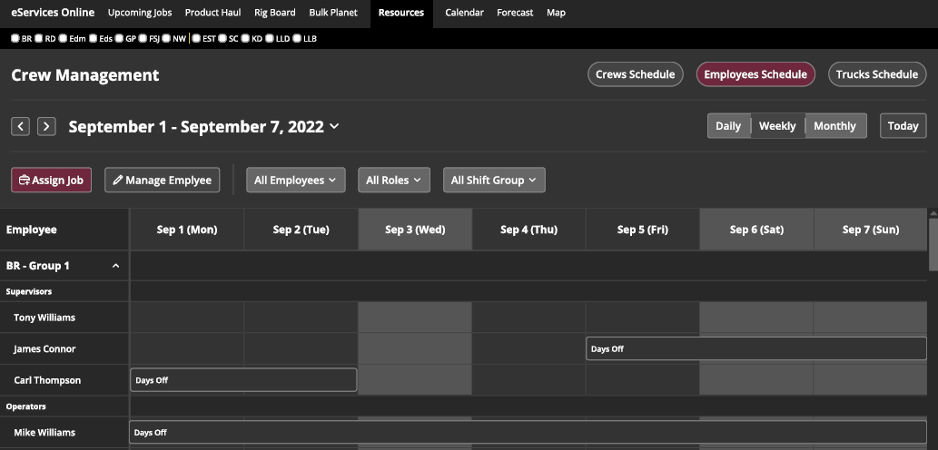

* **Do not require Assign Job**
  + **Used to see/modify availability**
  + **Ability to change days from available to Unavailable**
  + **Show vacation and other scheduled days**

* **Do not Assign Job**
  + **Used only to manage crews by operations & district managers**
  + **Need “Spare” list**
    - **Each district can add people to the Spare list**
    - **This is a list of guys that may added to crews in other districts**
      * **“Free Agents” / “Floaters” – able to help out other districts**
  + **Adjust crew name to Trailer #** 
    - **SCMT – trailer #, Bulker – trailer #, SCMS – truck # (There is no trailer)**
    - **Truck # to be referenced in all sheets**
      * **If a truck is changed, the crew name will be updated**
    - **If a job is “In Progress”, eService no longer allows changes, crew cannot be changed (same rules as eService)**
      * **If a job is forecasted, alerted, pending, confirmed, scheduled or dispatched the crew can be updated**

* **Add Crews:** 
  + **Do not need Home District (may be different for each crew member)**
  + **Add Operating District – default to home district (if the same for all people, leave empty if different)**
    - **Operating district can change**
      * **Based on job allocation**
      * **Selected by manager**
      * **Modified by Dispatch**

* **Job Hover**
  + **Add call sheet #**
  + **Color complexity score – green, yellow, red and black**
    - **>=60 Green**
    - **60>X<80 Yellow**
    - **>=80 X <120 Red**
    - **>=120 Black**

* **People Hover**
  + **Remove Hours available today**
    - **We do not have all this information yet – will be in the future**
      * **Hours available, hours remaining, reset time etc**
  + **Certifications will be added last in the project**
    - **This may be large due to client specific requirements**

* **District filter**
  + **When district filter is applied:**
    - **Show jobs by rigs assigned to district**
    - **Show crews with operating district = filter**
    - **Ability for dispatch to change crew operating district for it to show up, if the crew is currently assigned to another operating district**

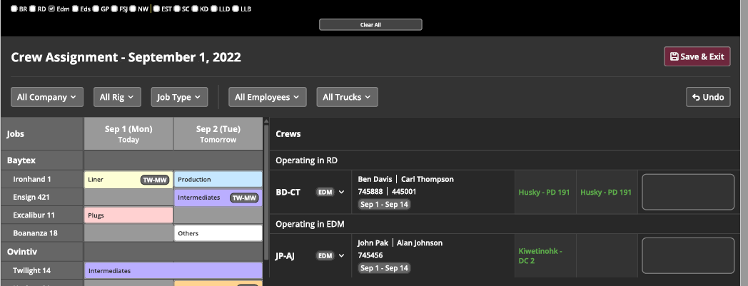

* **From above window, add a view of the crew assignments in a rolling 48 hr window**
  + **Will aid in seeing conflicts**
  + **Crew name (truck #) on the left**
  + **Rolling 48 hour time on the top**
  + **Assigned jobs on the grid – job 1 and job 2**
    - **Any status, does not need to be confirmed**

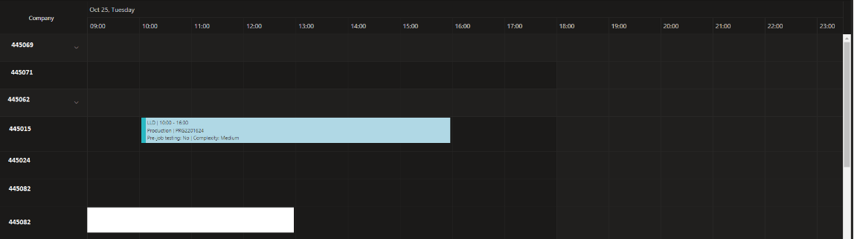

* **Job Assigned and Crew Changes**
  + **Job 1 will turn green once it is “In Progress”**
  + **No further changes can be made to an “In Progress” job, job 1**
  + **If a change to the crew is made, it will only affect job 2. There will be no impact on job 1 since it is “In Progress”**
    - **Need to follow eService status rules**
  + **When adding crew to a job, will need to add “Call Crew Time”**
    - **The following is from eService when assigning a crew**
      * **Job duration is already estimated – no entry required**

